Submitting Financial Disclosure Forms in the Abbott EDC Study Portal
Click on the E-Logs module to launch the Electronic Logs application.
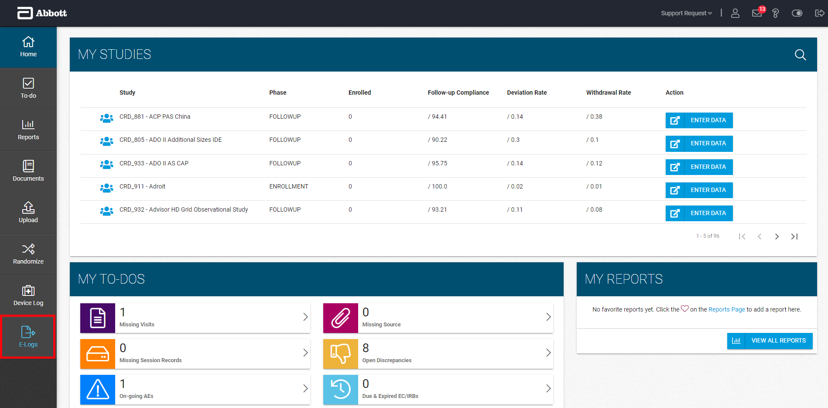
Dashboard
- If any of your study-sites are listed in the Dashboard with a count in the Site Action Items column, click on the Launch () icon to access that study-site document.
or
- If not, you can also click on the Financial Disclosure Form module on the left and then pick your study and site in the drop-downs available.


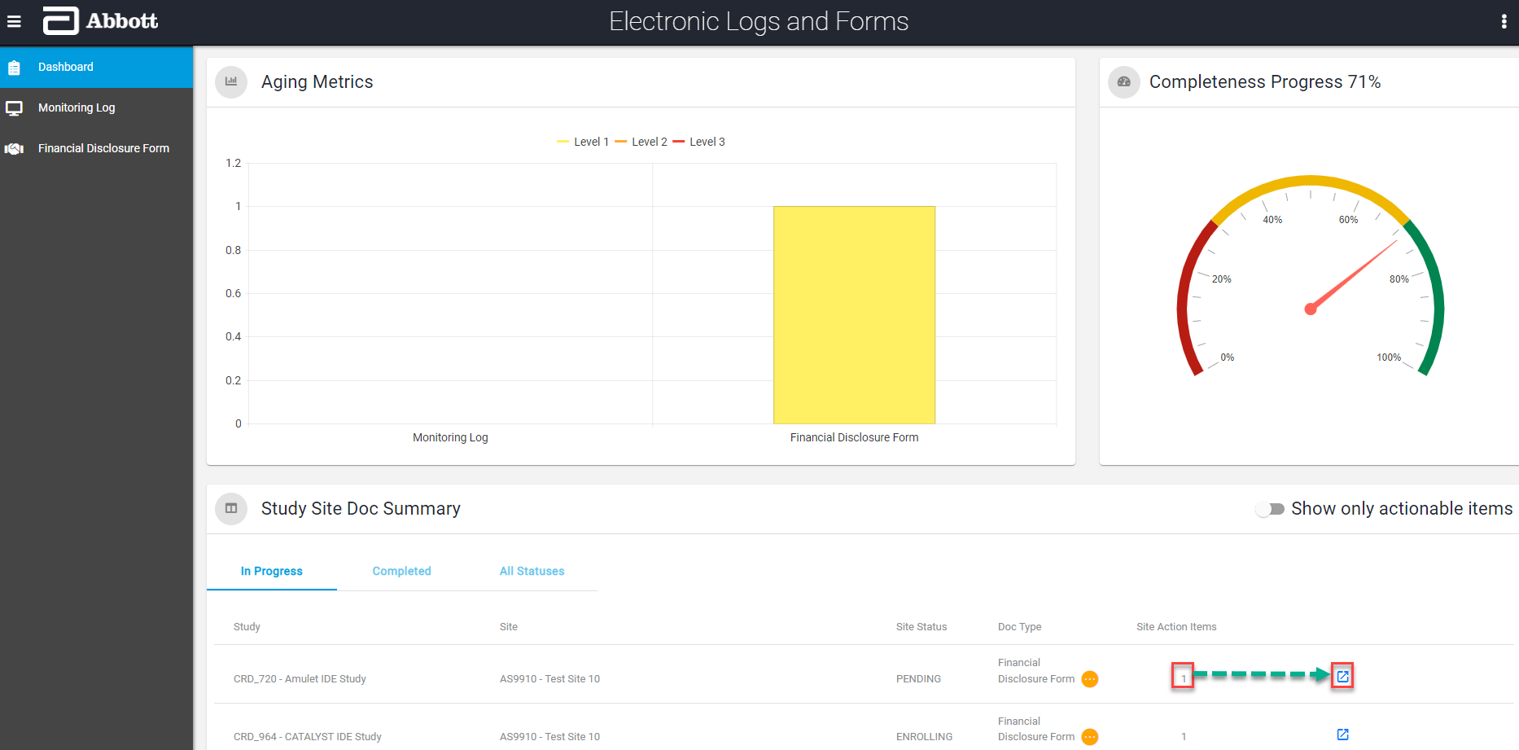
Financial Disclosure Form
- Once the study and site are selected, expand your line and click on the options () icon for the appropriate Timepoint and select
  - “Create Form” to create a new form or
  - “Edit Form” to change an existing form.
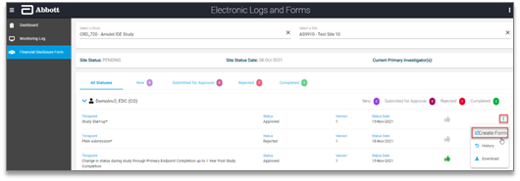
- The Financial Disclosure Form launches, and you can either select the thumbs up (agreement) or thumbs down (disagreement)* icon for each statement on the form.
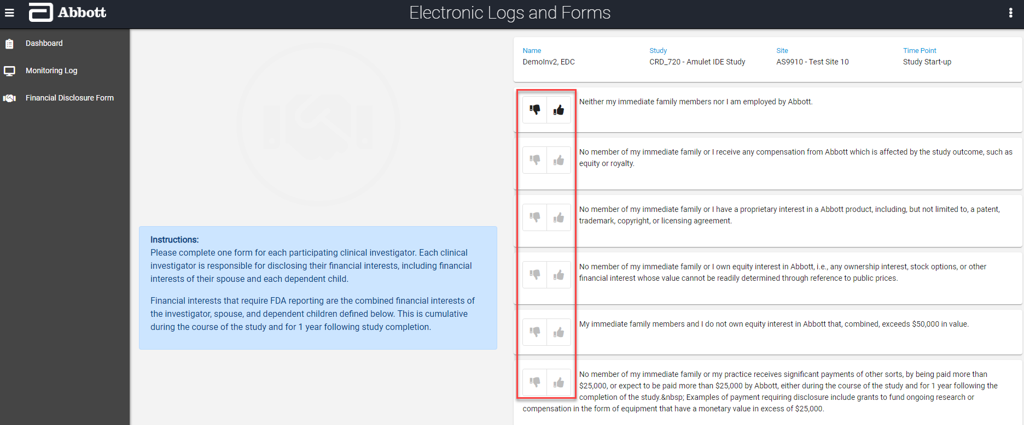

*An explanation is required for each disagreement.

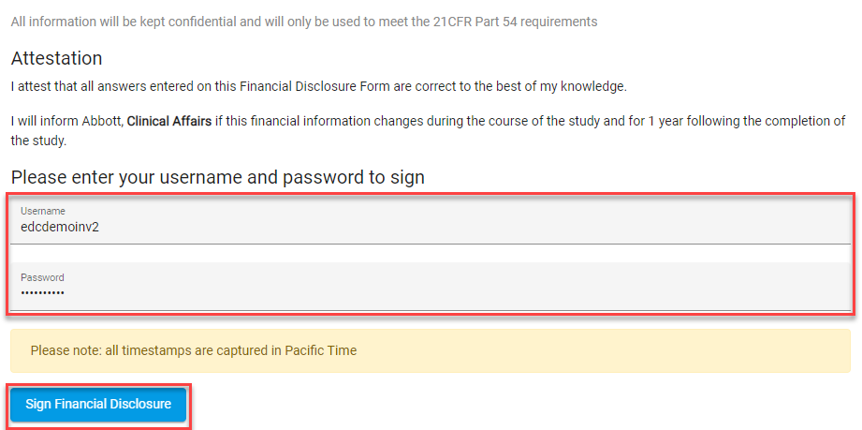
- Once you are done choosing an answer for all six statements on the form, you will enter your Abbott EDC Study Portal Username and Password, and then click Sign Financial Disclosure.

- Once you complete and sign the form, a confirmation will pop up with a link that you can use to go back to the Financial Disclosures screen and download your form for your regulatory binder.
